Kubernetes Task-01

- Setup Minikube in your local machine.

Step 1: Check prerequisites
Open PowerShell and check whether kubectl is installed:
kubectl version –client

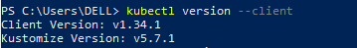

Also check Docker:
docker version
You should have Docker Desktop running because we can use Docker as the Minikube driver.
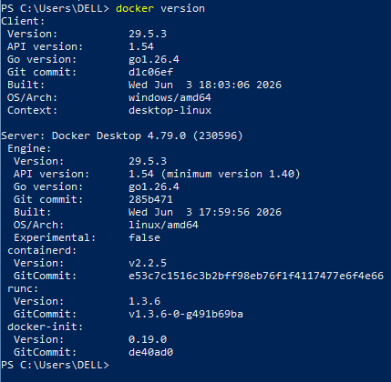

Step 2: Install Minikube
Install Minikube from the official documentation:
Minikube official installation documentation
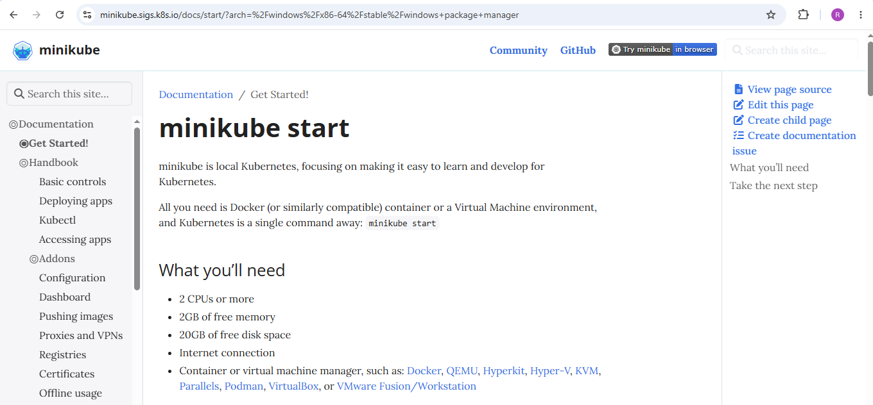
Select windows → x86-64 →stable →windows package manage
We will be able to see winget install Kubernetes.minikube command copy it and run on powershell.
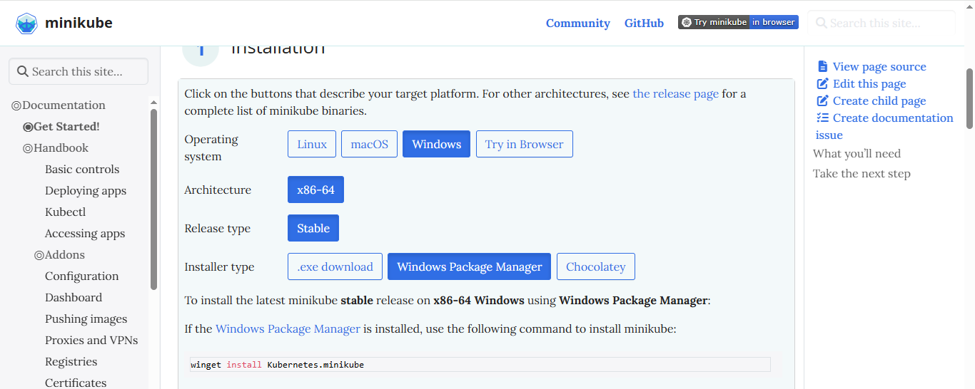
Minikube is installed.
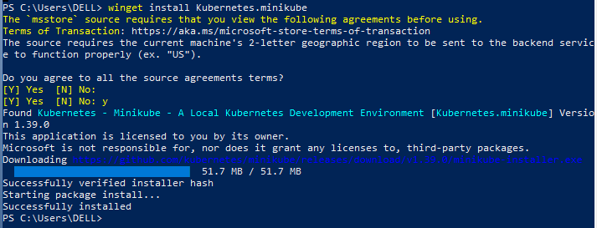

Step 3: Start Minikube
Make sure Docker Desktop is running.
Then execute: minikube start --driver=docker
Minikube will create a Kubernetes cluster using Docker.
You should eventually see something similar to:
Done! kubectl is now configured to use "minikube" cluster
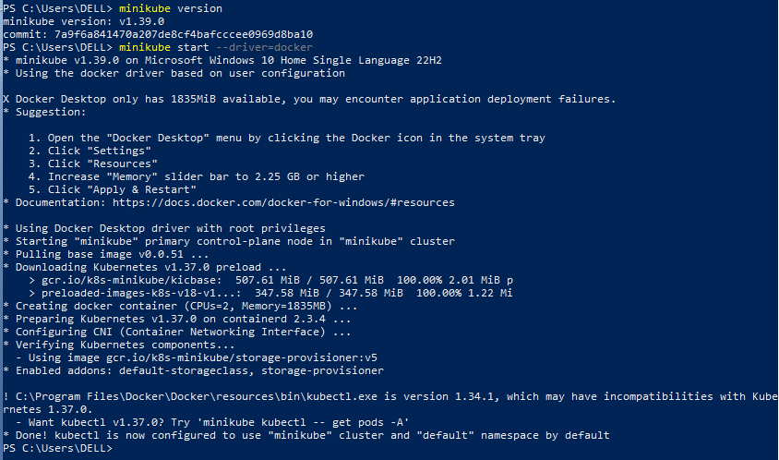

Step 4: Check Minikube status
Run: minikube status
Expected output:
host: Running
kubelet: Running
apiserver: Running
kubeconfig: Configured
This confirms that your Minikube Kubernetes cluster is running.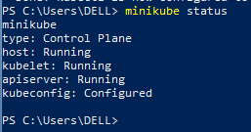

Step 5: Check Kubernetes nodes
Run: kubectl get nodes
Expected:
NAME STATUS ROLES AGE VERSION
minikube Ready control-plane ... v...
The important part is:
STATUS
Ready
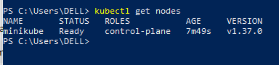

Step 6: Check Pods
Now run:
kubectl get pods -A
This shows Pods from all namespaces.
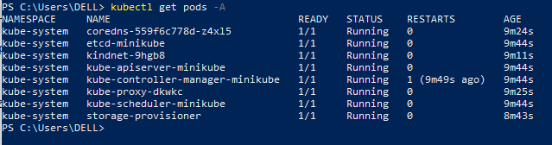
For more details:
kubectl get pods -A -o wide
This is the command you asked about earlier. It will show things like:
NAMESPACE NAME READY STATUS IP NODE
kube-system coredns-xxxxx 1/1 Running 10.244... minikube

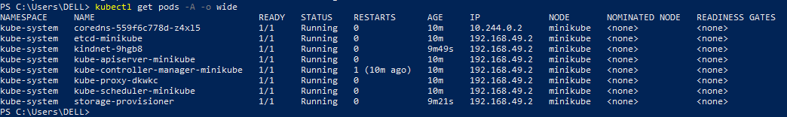

Step 7: Check Minikube cluster information
Run:
kubectl cluster-info
You should get information about the Kubernetes control plane.
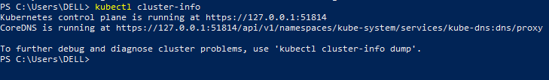
You can also run:
minikube dashboard
This opens the Kubernetes Dashboard in your browser.
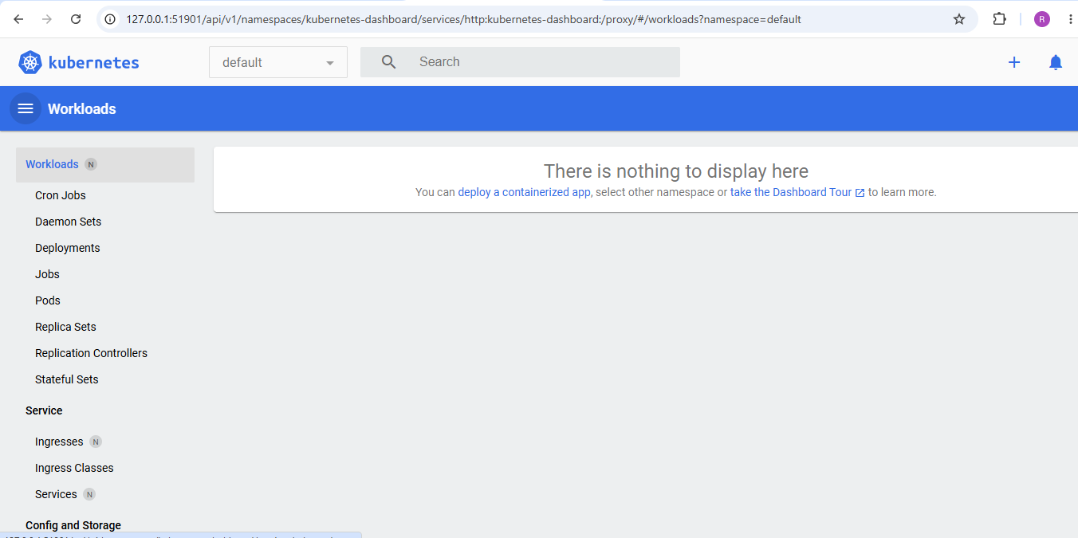

2. Setup k8s master and two worker nodes on ubuntu.

Kubernetes Cluster: 1 Master + 2 Workers

Architecture
Kubernetes Cluster
|
┌────────▼──────── ┐
│ Master Node │
│ Control Plane │
│ Ubuntu │
└────────┬──────── ┘
|
┌──────────┴────────── ┐
│ │
┌──────▼──────┐ ┌──────▼────── ┐
│ Worker Node │ │ Worker Node │
│ 1 │ │ 2 │
│ Ubuntu │ │ Ubuntu │
└─────────────┘ └───────────── ┘

STEP 1 — Create 3 Ubuntu machines
If using AWS EC2, create:
Instance | Hostname | Role
Ubuntu 1 | k8s-master | Control Plane
Ubuntu 2 | k8s-worker1 | Worker
Ubuntu 3 | k8s-worker2 | Worker
Select 2 vCPU and 2–4 GB RAM per machine.
Make sure all 3 instances are in the same VPC and preferably the same subnet/AZ.
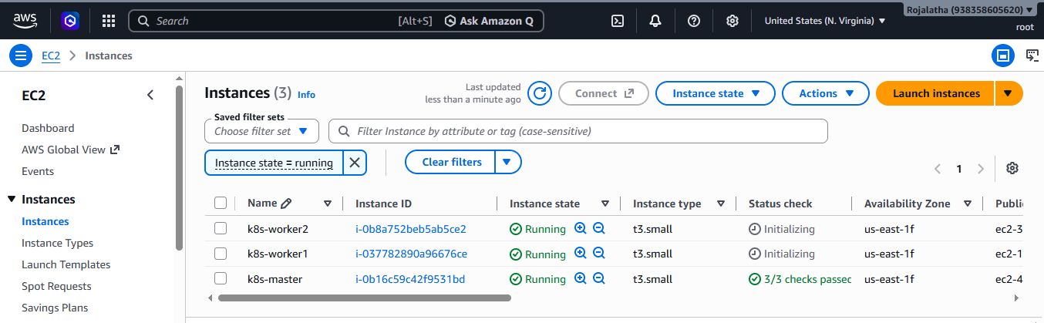

STEP 3 — Connect to the MASTER
Check the OS:
cat /etc/os-release
Check IP:
hostname -I

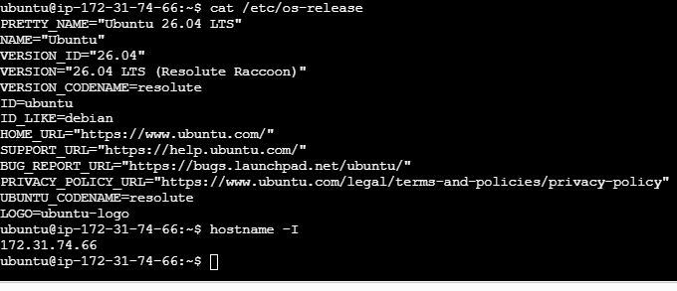

STEP 4 — Configure /etc/hosts
You want each machine to be able to resolve the other Kubernetes nodes.
First find the private IPs.
On all three machines, edit:
sudo vi /etc/hosts
Add:
Master 172.31.74.66
Worker1 172.31.79.160
Worker2 172.31.71.65
Use your actual private IP addresses, not these example addresses.
Test:
ping -c 2 172.31.74.66
ping -c 2 172.31.79.160
ping -c 2 172.31.71.65

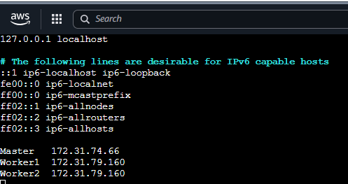
Checked the connectivity on master:
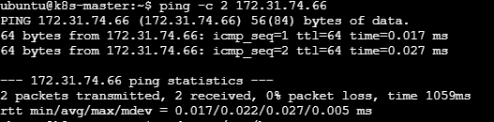
Checked the connectivity on worker2:
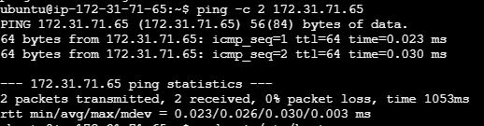
Checked the connectivity on worker1:
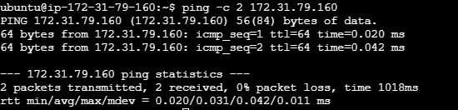
STEP 5— Load required kernel modules
Executed the below commands on master
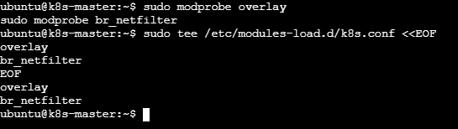

On worker1:
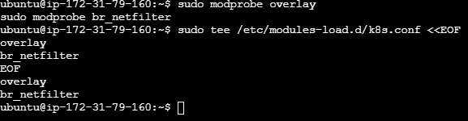
On worker2:
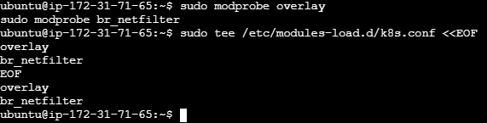
STEP 6 — Configure Kubernetes networking
On master machine: On worker1:
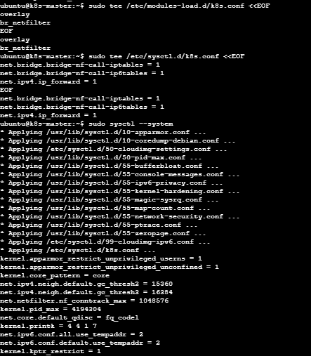
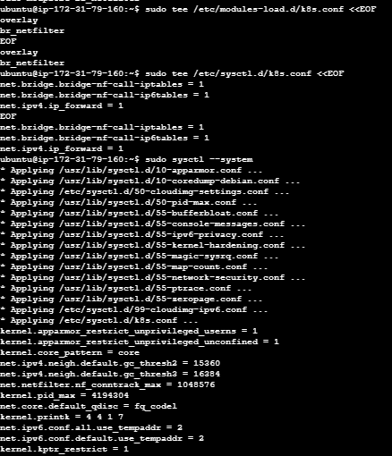

On worker2 :
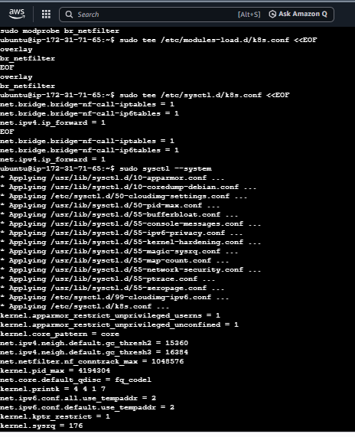
STEP 7— Install containerd
Kubernetes needs a container runtime.
We'll use containerd.
Run on ALL THREE MACHINES:
sudo apt-get update on master machine
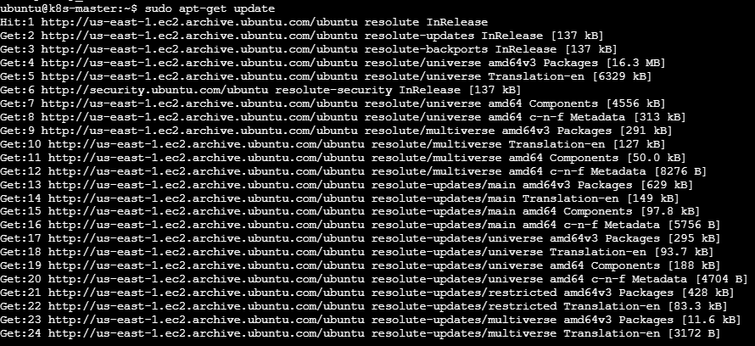

On worker1:

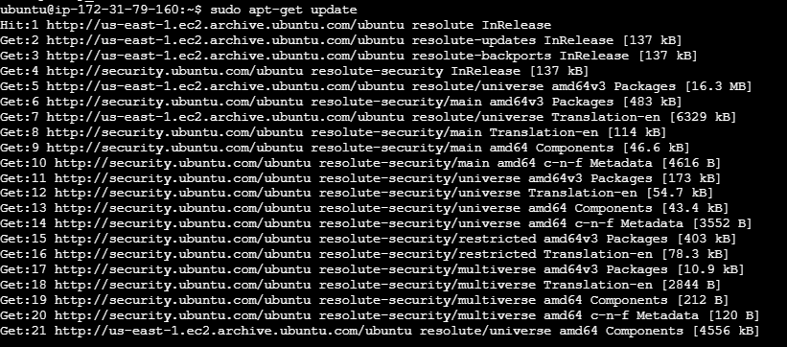

On worker2:
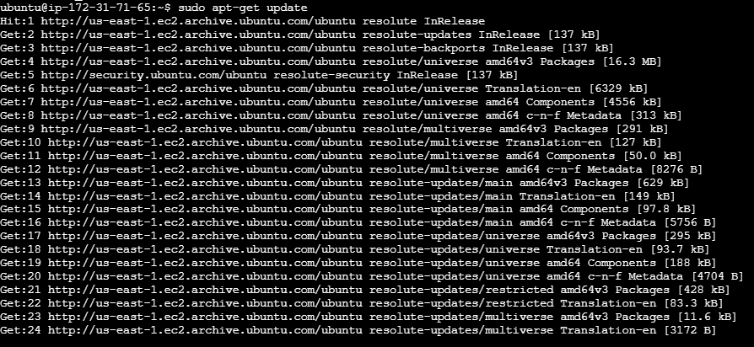
Then:
sudo apt-get install -y containerd
On master:
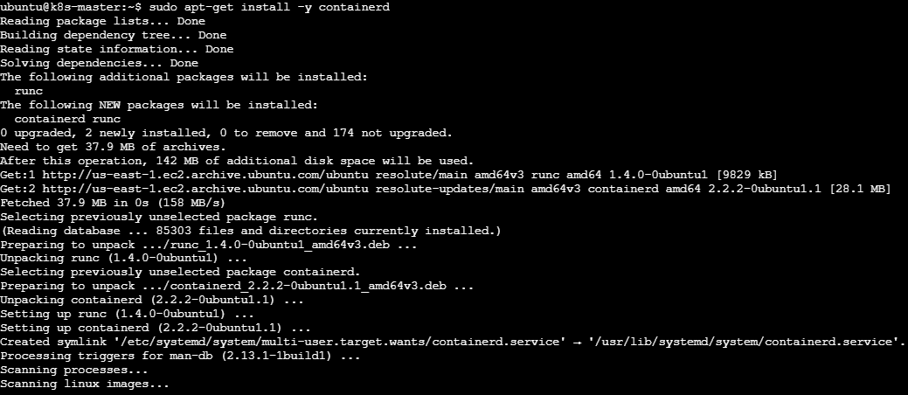

On worker1:
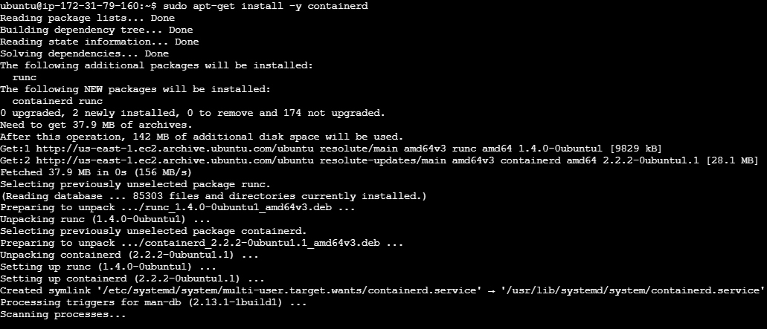
On worker2:
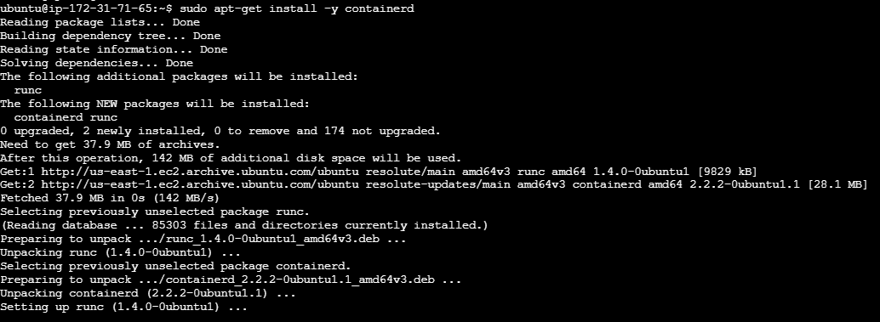
Check:
containerd --version
On three machines containerd version is
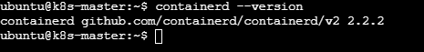

STEP 8 — Configure containerd
Run on ALL THREE MACHINES:
On Master:
Create the configuration directory:
sudo mkdir -p /etc/containerd
Generate the default configuration: containerd config default | sudo tee /etc/containerd/config.toml
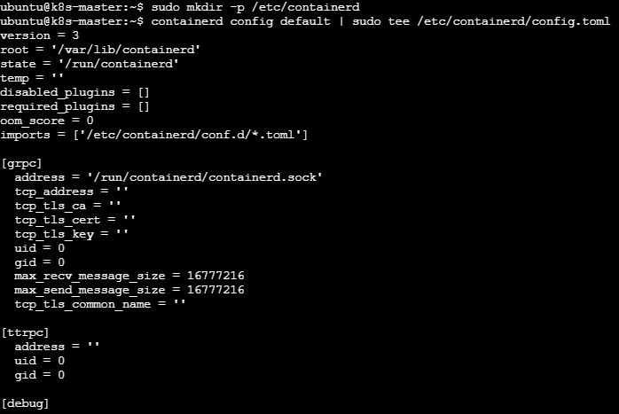
Now change containerd to use the systemd cgroup driver:
sudo sed -i 's/SystemdCgroup = false/SystemdCgroup = true/' /etc/containerd/config.toml
Restart containerd: sudo systemctl restart containerd
Enable it: sudo systemctl enable containerd
Check: sudo systemctl status containerd
You want: Active: active (running)
Press: q
to exit the status screen.
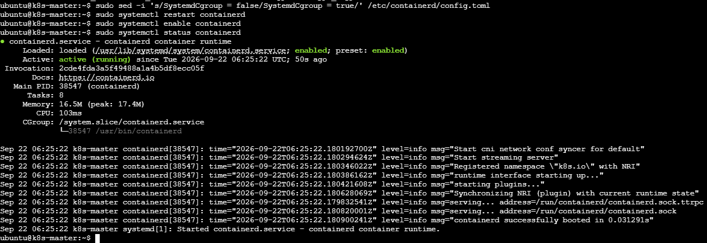
On worker1:
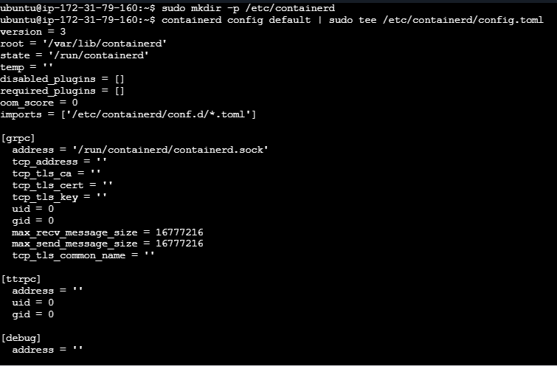
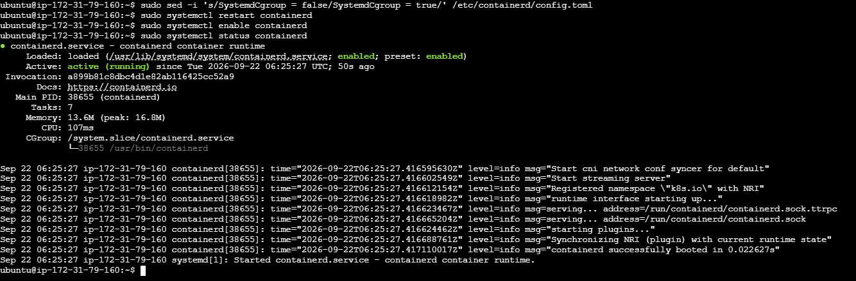
On worker2:
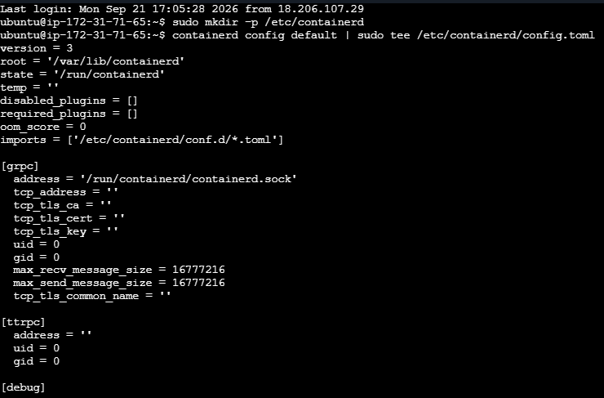
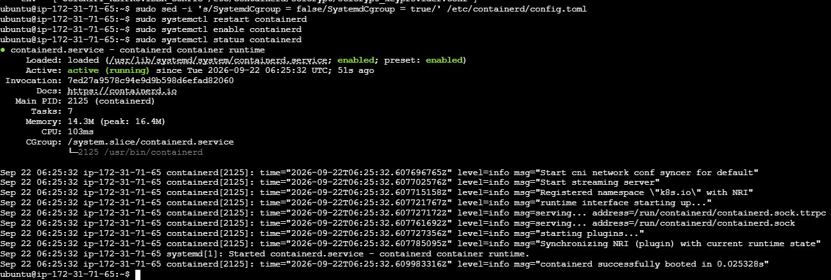

STEP 09 — Install kubeadm, kubelet and kubectl
We will install the Kubernetes packages from the official Kubernetes package repository.
Run this on ALL THREE MACHINES:
sudo apt-get update
sudo apt-get install -y apt-transport-https ca-certificates curl gpg

On master:
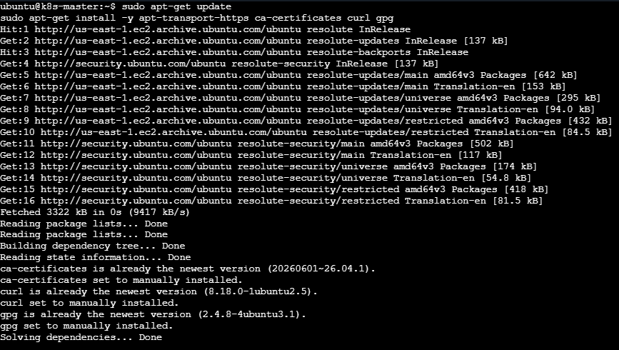

On worker1:
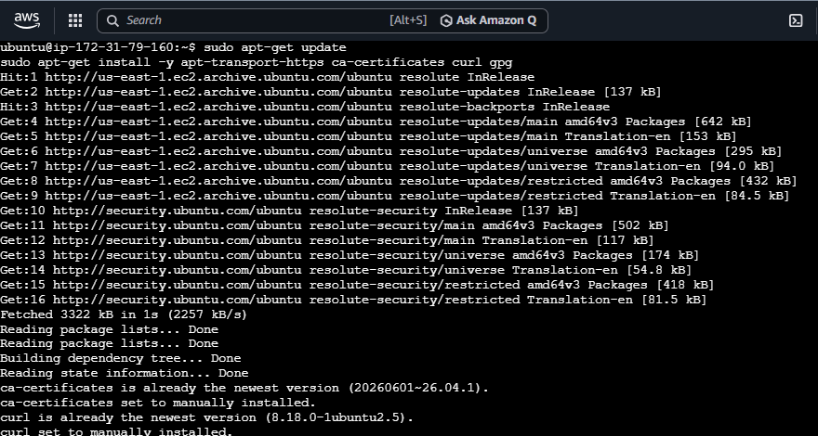
On worker2:
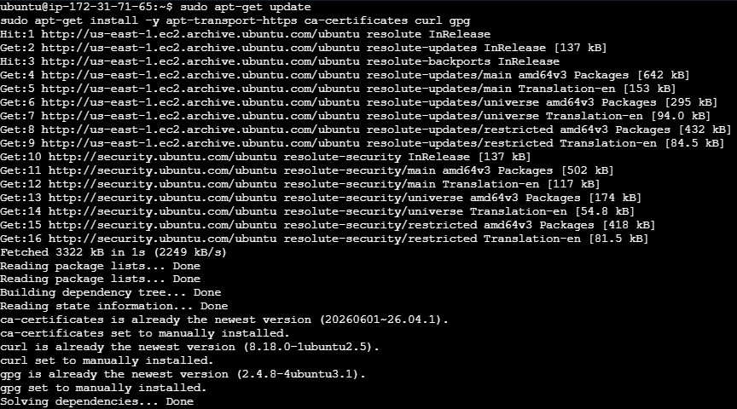
Create the keyring directory:
sudo mkdir -p -m 755 /etc/apt/keyrings
Add the Kubernetes signing key, add the repository and update packages
On master:
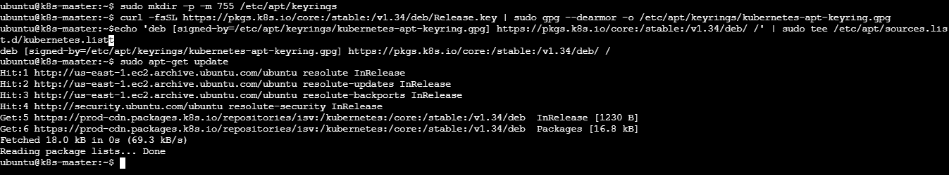
On worker1:
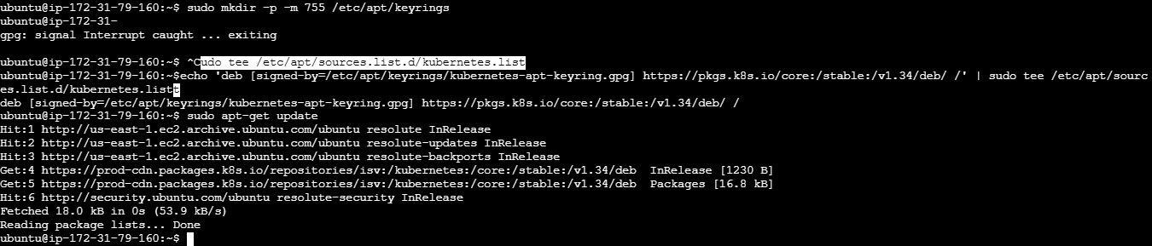
On worker2:
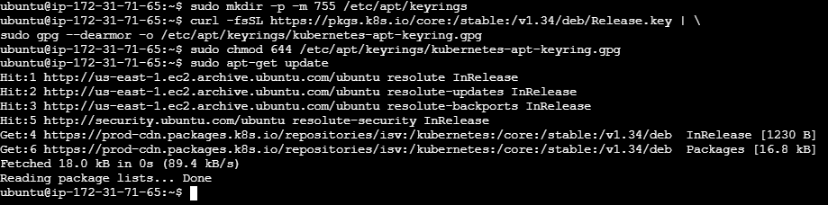

Install: sudo apt-get install -y kubelet kubeadm kubectl
On master:
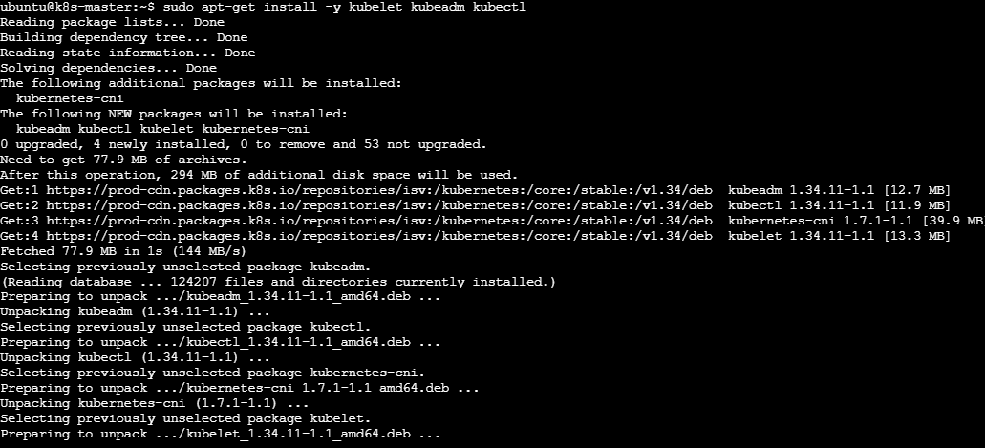
On worker1:
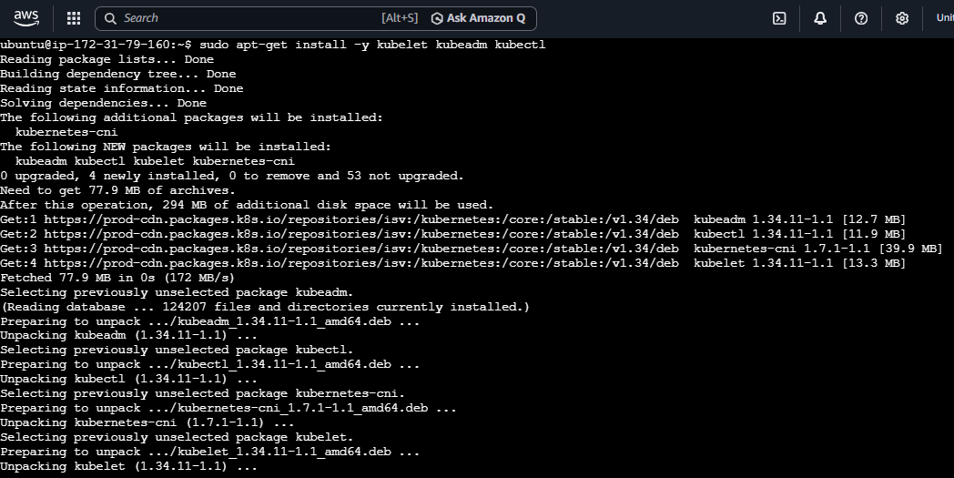
On worker2:
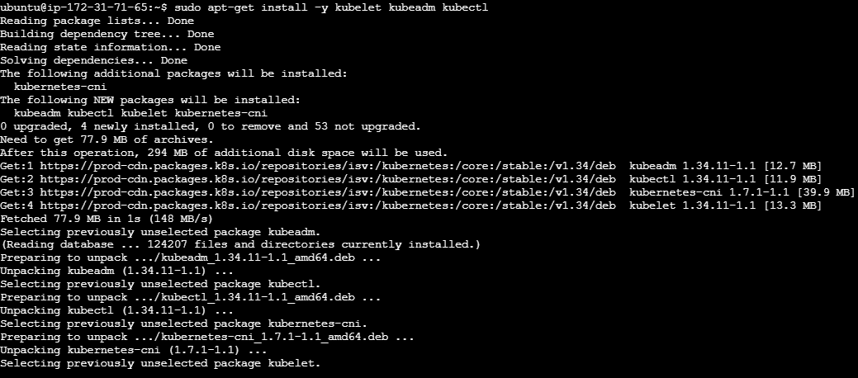
Prevent automatic upgrades: sudo apt-mark hold kubelet kubeadm kubectl
Check:
kubeadm version
kubectl version --client
kubelet --version

On master:

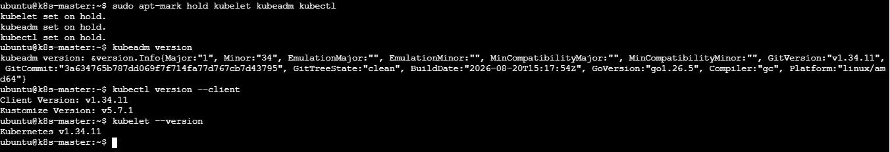

On worker1:
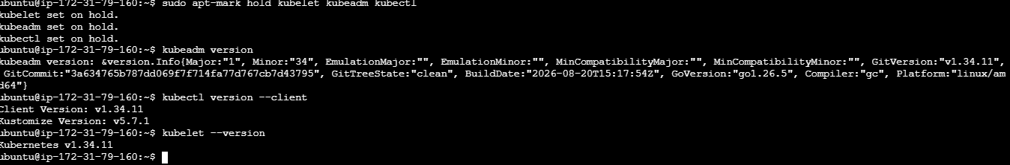
On worker2:
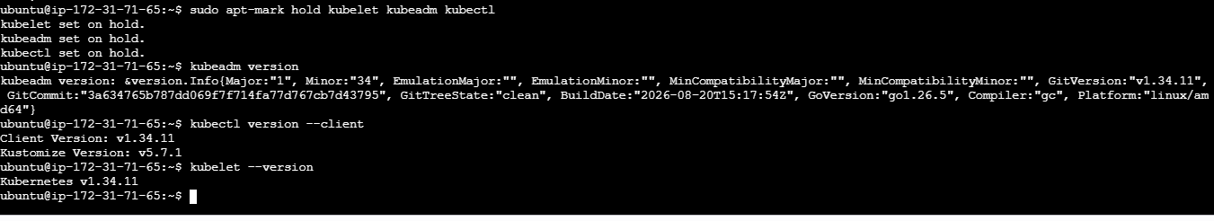

STEP 10 — Enable kubelet
Run on ALL THREE MACHINES:
sudo systemctl enable kubelet
The kubelet may not be fully running yet on the worker nodes. That is normal because they haven't joined the cluster.
On master:
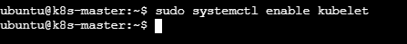
On worker1:
On worker2:

STEP 11 — Initialize the MASTER
Now switch to your MASTER only.
First find the master's private IP:
hostname -I
Suppose it is:
10.0.1.10
Initialize Kubernetes:
sudo kubeadm init --apiserver-advertise-address=10.0.1.10 --pod-network-cidr=192.168.0.0/16
Replace 10.0.1.10 with your master's actual private IP.
This may take several minutes.
At the end, kubeadm will display a command similar to:
kubeadm join 10.0.1.10:6443 --token xxxxx \
--discovery-token-ca-cert-hash sha256:xxxxx

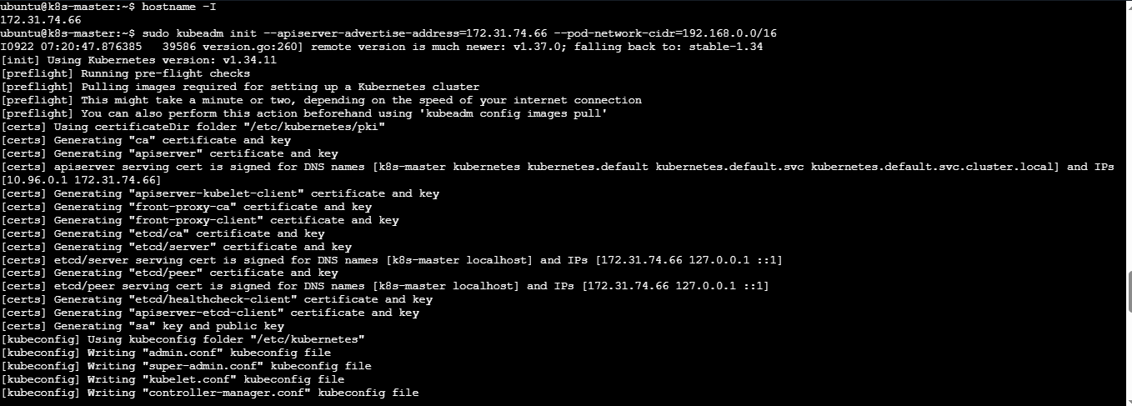

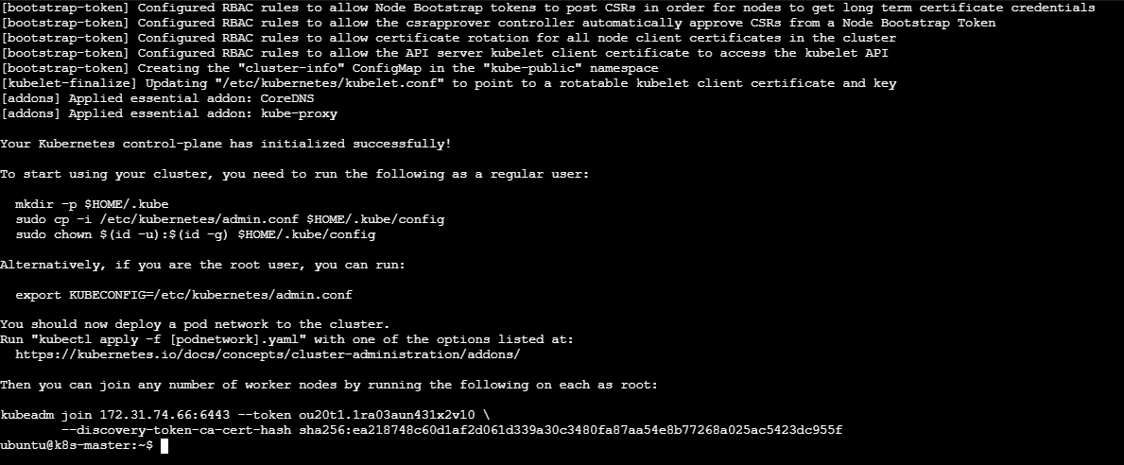

VERY IMPORTANT
Save this kubeadm join command.
kubeadm join 172.31.74.66:6443 --token ou20t1.1ra03aun431x2v10 \
--discovery-token-ca-cert-hash sha256:ea218748c60d1af2d061d339a30c3480fa87aa54e8b77268a025ac5423dc955f
You will use it on Worker 1 and Worker 2.

STEP 12 — Configure kubectl on MASTER
Still on the master: mkdir -p $HOME/.kube
Then:
sudo cp -i /etc/kubernetes/admin.conf $HOME/.kube/config
Change ownership:
sudo chown $(id -u):$(id -g) $HOME/.kube/config
Test:
kubectl get nodes
At this point you may see:
NAME STATUS ROLES AGE
k8s-master NotReady control-plane ...
Not Ready is expected right now.
We haven't installed the Pod network yet.
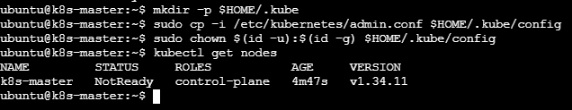

STEP 13 — Install a Pod network
We'll use Calico for this example.
On the MASTER:
kubectl apply -f https://raw.githubusercontent.com/projectcalico/calico/v3.30.3/manifests/calico.yaml

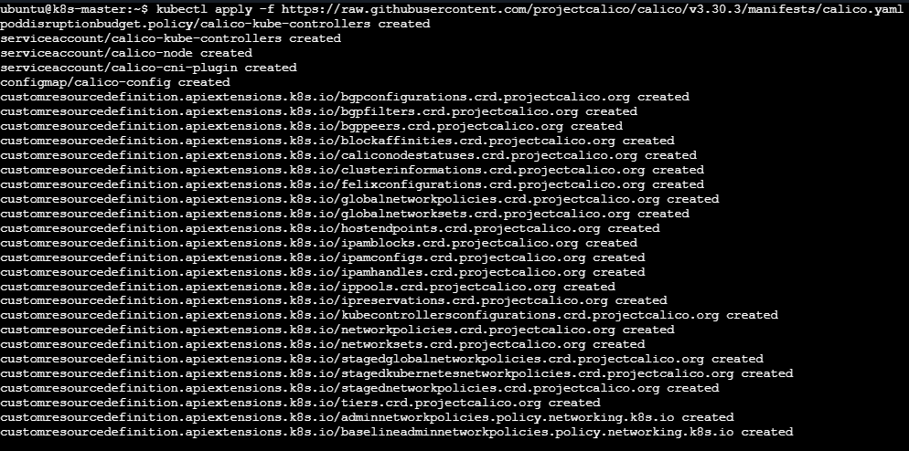
Check:
kubectl get pods –A
Wait for the Calico pods to become Running.
Then:
kubectl get nodes
The master should eventually become:
NAME STATUS ROLES AGE
k8s-master Ready control-plane ...

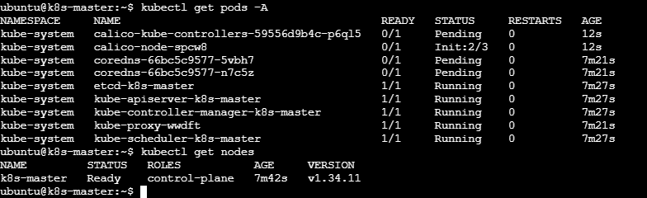

STEP 14— Join Worker 1 and worker 2
Now connect to Worker 1 and worker 2
Run the kubeadm join command that was displayed by kubeadm init on both the workers.
It will look like:
kubeadm join 172.31.74.66:6443 --token ou20t1.1ra03aun431x2v10 \
--discovery-token-ca-cert-hash sha256:ea218748c60d1af2d061d339a30c3480fa87aa54e8b77268a025ac5423dc955f
If successful, you'll see something similar to:
This node has joined the cluster

Worker1:
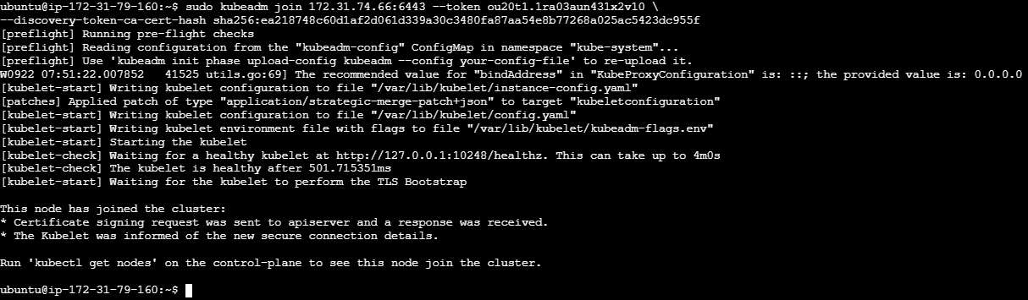

Worker2:
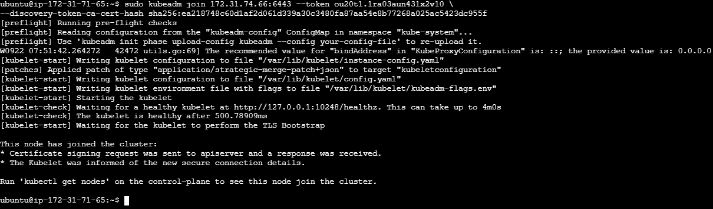

STEP 16 — Verify the entire cluster
Go back to the MASTER.
Run:
kubectl get nodes
You want:
NAME STATUS ROLES AGE VERSION
k8s-master Ready control-plane ... v1.34.x
k8s-worker1 Ready <none> ... v1.34.x
k8s-worker2 Ready <none> ... v1.34.x
1-master + 2-worker Kubernetes cluster is now ready.
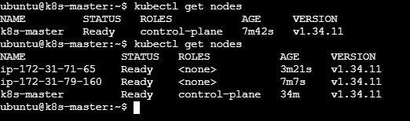

STEP 17— Check all Kubernetes system Pods
Run:
kubectl get pods -A
You should see components:
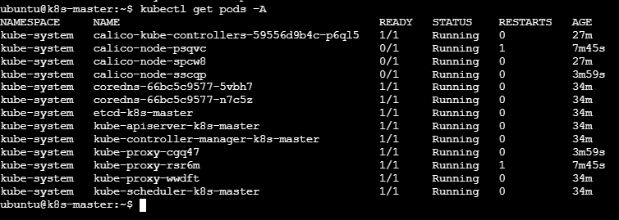
And Calico pods should also be running.

STEP 18 — Test the cluster with a Pod
On the master:
kubectl create deployment nginx --image=nginx
Check:
kubectl get pods -o wide
Notice the NODE column.
Your application Pod should normally be scheduled onto a worker, not the control-plane node.

STEP 19— Expose nginx
Run:
kubectl expose deployment nginx --port=80 --type=NodePort
Check:
kubectl get svc
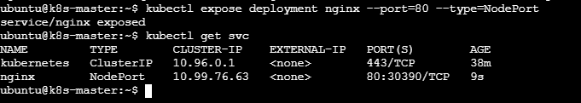
3. Run one nginx pod.

Step 1: Make sure you are on the Master
Run: kubectl get nodes
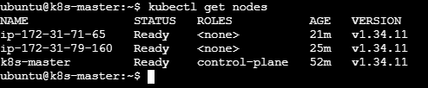
Step 2: Create one Nginx Pod
Run this on the master:
kubectl run nginx --image=nginx
You should get:
pod/nginx created

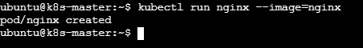

Step 3: Check the Pod
Run:
kubectl get pods

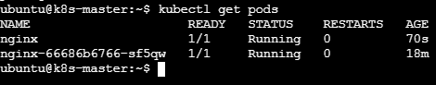
The important part is:
STATUS
Running

Step 4: Find which worker is running Nginx
Run:
kubectl get pods -o wide

Here you can see: NODE = k8s-worker1
Kubernetes automatically scheduled the Nginx Pod onto a worker node.

Step 5: Get more information about the Pod
Run:
kubectl describe pod nginx
This shows details such as:
- Pod name
- Node where it is running
- Container image
- Pod IP
- Events
- Container status
